|  |
| --- |
| **What is an Embedded System?**  An embedded system is a computer that serves a dedicated purpose involving computation for real-time operations. Embedded systems are all around us in consumer, industrial, telecommunication and even medical applications.  Embedded systems can have varying degrees of complexity, ranging from a simple thermometer to modern smartphones. Today, the demand for capable embedded systems are on the rise as modern applications such as machine learning make their way into consumer devices. |

|  |
| --- |
| **What is Embedded Linux used for?**  Embedded Linux is a type of Linux kernel that is specially designed for embedded devices. For example, the popular smartphone operating system, Android, is a type of embedded Linux customised for smartphones. |

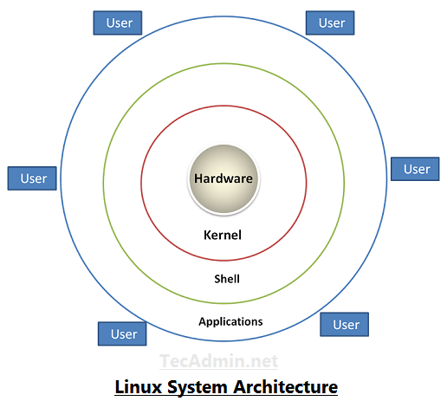

In simple terms, a kernel is the core of an operating system that manages the operations of the computer and its hardware, especially the memory and CPU. In other words, the kernel is the interface between software and hardware.

For more details on the Linux architecture, George Hilliard offers a [great breakdown and introduction](https://www.thirtythreeforty.net/posts/2019/08/mastering-embedded-linux-part-1-concepts/).

**Why Embedded Linux?**

If you are trying to create your own project, developing a kernel from scratch for your hardware is an incredibly challenging process, since it requires deep knowledge of both hardware and code.

You may also have heard of bare-metal tasking kernels (without an operating system) for microcontrollers, such as FreeRTOS, Azure RTOS, RT-Thread, μC/OS, but these choices lack memory management and protection which are critical to building modern applications. Because of this, you may be looking for a more comprehensive solution.

Fortunately, there are many advantages of using embedded Linux on a microprocessor in your embedded applications, such as built-in dynamic memory management and security modules that you might want to consider.

**Linux has Extensive Compatibility**

Over the years, Linux has grown to support a large variety of CPU architectures, including x86, ARM and PowerPC etc. So, no matter what kind of hardware you are working with, there is a good chance that a Linux kernel already exists for it.

Linux supports nearly all the programming languages and utilities that you need for your embedded system development endeavours. With Linux, you are not restricted to any specific software. If you are dissatisfied with anything, there is a good chance that an alternative is available – or you can be the first in the community to develop it!

**Linux is Open Source**

Linux, as an open source kernel, allows you to leverage on the work of thousands of developers across the world. By tweaking or directly implementing existing packages, you can get your own applications up and running far more easily and quickly.

**The Linux Community is There for You**

Got a specific question? No problem! Because Linux is used by so many developers, you not only have their code to count on, but also their experience and knowledge. Simply ask away at one of the many forums available, like [linux.org](http://linux.org/).

**Get Started with Embedded Linux Boards**

Now that we’ve learnt more about the advantages of embedded Linux, it’s time to explore how we can get into it!

The best way to dive into the world of embedded Linux is to get your hands on a single board computer. Today, there are many available single board computers that ship with specialised embedded Linux distributions, that are available for you to directly begin developing and using in your own projects.

**Choosing from Linux Distributions**

Linux distributions or “distros” are different flavours of operating systems running on the Linux kernel. They may offer different in-built features or tools, allowing for a variety of user and development experiences.

To make better use of limited resources on embedded devices, server distributions do not come with a GUI or graphical user interface. Instead, the command line interface will have to be used.

* [Ubuntu (Desktop / Server)](https://ubuntu.com/)
* [Ubuntu MATE (Desktop / Server)](https://ubuntu-mate.org/)
* [Debian](https://www.debian.org/)
* [Red Hat](https://www.redhat.com/en/technologies/linux-platforms/enterprise-linux)

For even more recommended Linux distros for beginners, please visit [Best Linux Distros 2020 for Beginners](https://www.seeedstudio.com/blog/2020/06/30/best-Linux-distros-2020-for-beginners).

**Raspberry Pi OS – Raspberry Pi 4**

One popular and cost-effective embedded Linux solution is offered by the [Raspberry Pi 4](https://www.seeedstudio.com/Raspberry-Pi-4-Computer-Model-B-4GB-p-4077.html), which comes with its very own Raspberry Pi OS operating system. The desktop OS is very beginner friendly and easy to use, with official guided tutorials from the Raspberry Pi Foundation and extensive community support.

**More Embedded Linux Platforms**

You may also be interested in the following popular embedded Linux single board computers:

|  |  |  |  |
| --- | --- | --- | --- |
| **SBC** | **Operating System** | **Good For** | **Cost** |
| [Raspberry Pi Zero](https://www.seeedstudio.com/Raspberry-Pi-Zero-p-4254.html) /[Zero W](https://www.seeedstudio.com/Raspberry-Pi-Zero-W-p-4257.html) | Linux | Low cost and small form factor | $5 / $10 |
| [Raspberry Pi 4](https://www.seeedstudio.com/Raspberry-Pi-4-Computer-Model-B-4GB-p-4077.html) | Linux | Introduction and Learning with Great Support | $35 |
| [Odyssey – X86J4105864](https://www.seeedstudio.com/ODYSSEY-X86J4105864-Win10-Enterprise-Activated-p-4446.html) | Windows & Linux, with Arduino Co-processor | High performance edge computing development | $258 |
| [NVIDIA Jetson Nano 2GB Developer Kit](https://www.seeedstudio.com/NVIDIAr-Jetson-Nanotm-Developer-Kit-p-2916.html) | Linux | Beginner friendly Machine Learning Option | $59 |
| [NVIDIA Jetson Xavier NX Developer Kit](https://www.seeedstudio.com/NVIDIA-Jetson-Xavier-NX-Developer-Kit-p-4573.html) | Linux | High Performance AI and Machine Learning | $399 |

For more single board computers that can be used with embedded Linux and more, be sure to visit:[Raspberry Pi Alternatives: 17 Best Single Board Computers in 2020](https://www.seeedstudio.com/blog/2020/10/20/raspberry-pi-alternatives-17-best-single-board-computers-in-2020/).

**Embedded Linux: A Custom Solution**

If none of the existing Linux operating system options meet your needs, or if you simply like to do it yourself, you can get started building your custom embedded Linux system in a few ways.

[**Yocto**](https://www.yoctoproject.org/) – An open source collaboration project that provides a flexible set of tools and platform to create custom Linux-based systems regardless of hardware architecture.

[**Buildroot**](https://buildroot.org/)– A simple, efficient and easy-to-use tool to generate embedded Linux systems through cross-compilation.

[**OpenWrt**](https://openwrt.org/) – A highly customisable Linux framework for embedded devices (typically wireless routers)

For more information on each of these custom embedded Linux solutions, feel free to visit each of their websites for more information on how to get started.